TO DO:
Tag each sample as Bright (B) or Dark (D) for which band they are in and check their averages/std.
Age of each sample is determined based on the growth lines gathered by the X-Ray images taken. Each slab is X-ray scanned individually after they were sampled for the isotope analysis. In order to position the each samples on X-Ray image indicator notches carved on the slab. It is well known that the darkness of the patterns in the X-ray images indicates the density of the coral skeleton and the higher dense coral skeletons align with the seasons of stronger rainfall and higher temperatures \cite{buddemeier1974radiographic}. WHICH MONTH THIS INDICATES FOR SOLOMON baya kafalar karışık bu konuda! See section XX
Age Model:
Growth lines are set both sides of each dark (denser skeleton) band, to increase the amount of tie points used in the time interpolation. Older part of each dark band is assigned to be beginning of December and the younger part of the band is as end of May of each year. The tie points are set where a growth line intersects a sampling area, and all the other samplings in between are linearly interpolated for the sake of simplicity.
Path Merge:
The samples are taken along growth line perpendicular paths and
Signal Analysis:
Wavelet spectral analysis \cite{torrence1998practical} of both signals show the annual cycle throughout the time series with occasional gaps. The time windows where the annual is significantly present aligns in both signals, however $\delta^{18}$O signal has a much more stable annual periodicity compared to $\delta^{13}$C signal.
Both d13C and d18O signals are dominated by annual periodicity and both signals align with dark band phases. d13C and d18O are strongly off phase. The phase difference between detrended $\delta^{13}$C \& $\delta^{18}$O data sets are around 1.09$\pi$ and the correlation coefficient between two detrended time series are -0.91, which all aligns well with the observations in prior coral research \cite{darke1991growth}.

Observation:
The samples from the dark bands show a lower $\delta^{18}O$

THERE IS A PHASE SHIFT BETWEEN DARK BAND d18O and d13C!
Good to note:
Radiocarbon dating is problematic because of reservoir effects. U/Th is better but it has decadal uncertainties.

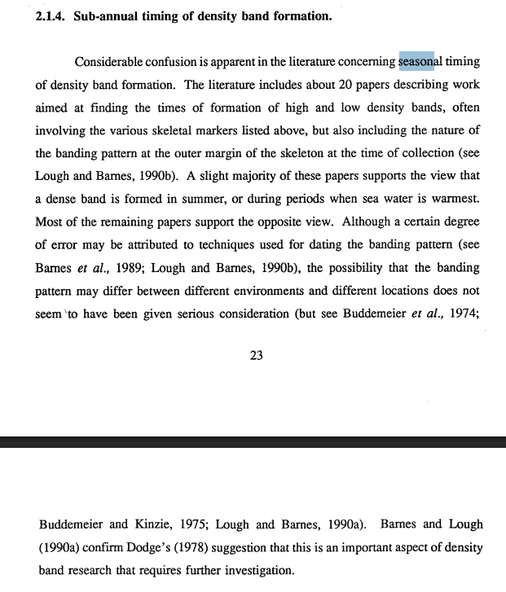
A single core extracted from a coral colony along the growth axis may be complete with little material missing in core breaks, but this is not typical with larger colonies (e.g., Quinn et al., 1998; Linsley et al., 2000; Urban et al., 2000; Ren et al., 2002). Growth orientation changes on the centimeter scale may produce ambiguous banding patterns in the X-radiographs resulting in locally absent years (Barnes et al., 1989; Lough and Barnes, 1997; Hendy et al., 2003; Alibert and Kinsley, 2008). False bands or stress bands visible in the X-radiographs add to the chronology uncertainty if these bands are counted (Hudson et al., 1976; Swart et al., 1996b). The core extraction process may produce breaks in the core or the core may contain cavities from bioerosion resulting in missing years (Hendy et al., 2003). Therefore, chronology uncertainty on the annual scale increases with age unless independent age verification such as high precision absolute thorium-230 (230Th) dating is used (Shen et al., 2008). Chronology uncertainty is estimated to be ±1 to 5 years century−1 for reconstructions with a single coral core (Swart et al., 1996b; Dunbar and Cole, 1999; Felis et al., 2000; DeLong et al., 2007; Shen et al., 2008).

We developed our own age model based on known methods from prior research. We prioritize matching our age model to local climate data set and than extrapolate the time window for the ages before the data set is available. We decided to not use the X-Ray growth band, since they might be misleading but the X-ray bands are used for spatial connections between different data sets gathered from the coral slab.
Each piece of slab is X-ray scanned individually after they were sampled for the isotope analysis. In order to position each sample on their path on X-Ray image, indicator notches carved at the end of every 6 sample. Each slab piece is carefully patched together in digital environment. Based on our X-ray images, each sample’s position in slab is known and this information is used to anchor the relative age of each individual path according to its neighboring paths.
As we also realized in our earlier age models, the density bands gathered from X-Ray radiography might deliver inaccurate age information.
The common counting errors based on false bands or stress bands lead to10 years older age for the last sample of the coral in our initial growth band counting. The growth band counting might be misleading in terms of absolute age modeling, however their barcode like unique structure allows us to use it for temporal-spatial interchanges. Beside the relative ages of the paths along the slab, we also use X-ray bands to match both of the coral’s morphology observations to each isotope results. The X-ray bands of 12-SPLA is used as a reference age model also for the 12-SPA.
Since we are working on a recent coral, our age model is based on pseudo coral forward model of Thompson et al (2011). Tie points are set between the pseudo coral and the d18o measurements we got. The forward model is a simple linear relationship based on sea surface temperature (SST) and sea surface salinity (SSS) where the coral is located. We used the geographically designated coefficients proposed by Thomspon et al (2011), alpha_1=-0.22 (‰/°C) and alpha_2=0.45. For both SSS and SST we used monthly ORAS5 from 1958 until 2007. We identified Annual cycles visually in the coral signal and matched one-to-one to the corresponding climate cycles. This produced a set of cycle boundary anchors in x-ray based pseudo-year space mapped to real calendar years. The anchor pairs from the peak matching were used to build a piecewise-linear warp function, converting the raw pseudo-years into a calibrated calendar years. The result spans 1958–2007 with r = 0.595 against the climate reference. For the years before climate data was available, we applied tie points based on the pseudo coral’s annual climate average.

https://cds.climate.copernicus.eu/datasets/reanalysis-oras5?tab=overview

Discussion
The growth rates based on our age model seems reasonable for an average growth rate of a porite around 1.1? (fig XX). One should also consider that we drilled our samples vertically which opposes to general drilling direction, so the growth rates might differ in horizontal direction than vertical growth rates in the literature. We also located our paths strategically avoiding any bioturbated tissues or getting close to the exposed surface, therefore we weren’t always able to follow optimal sampling path, apex of fan. Therefore the sampling rates have artefacts due to combination of sampling bath irregularities and our age modeling.

